Step 1:

Create IAM role : to get arn

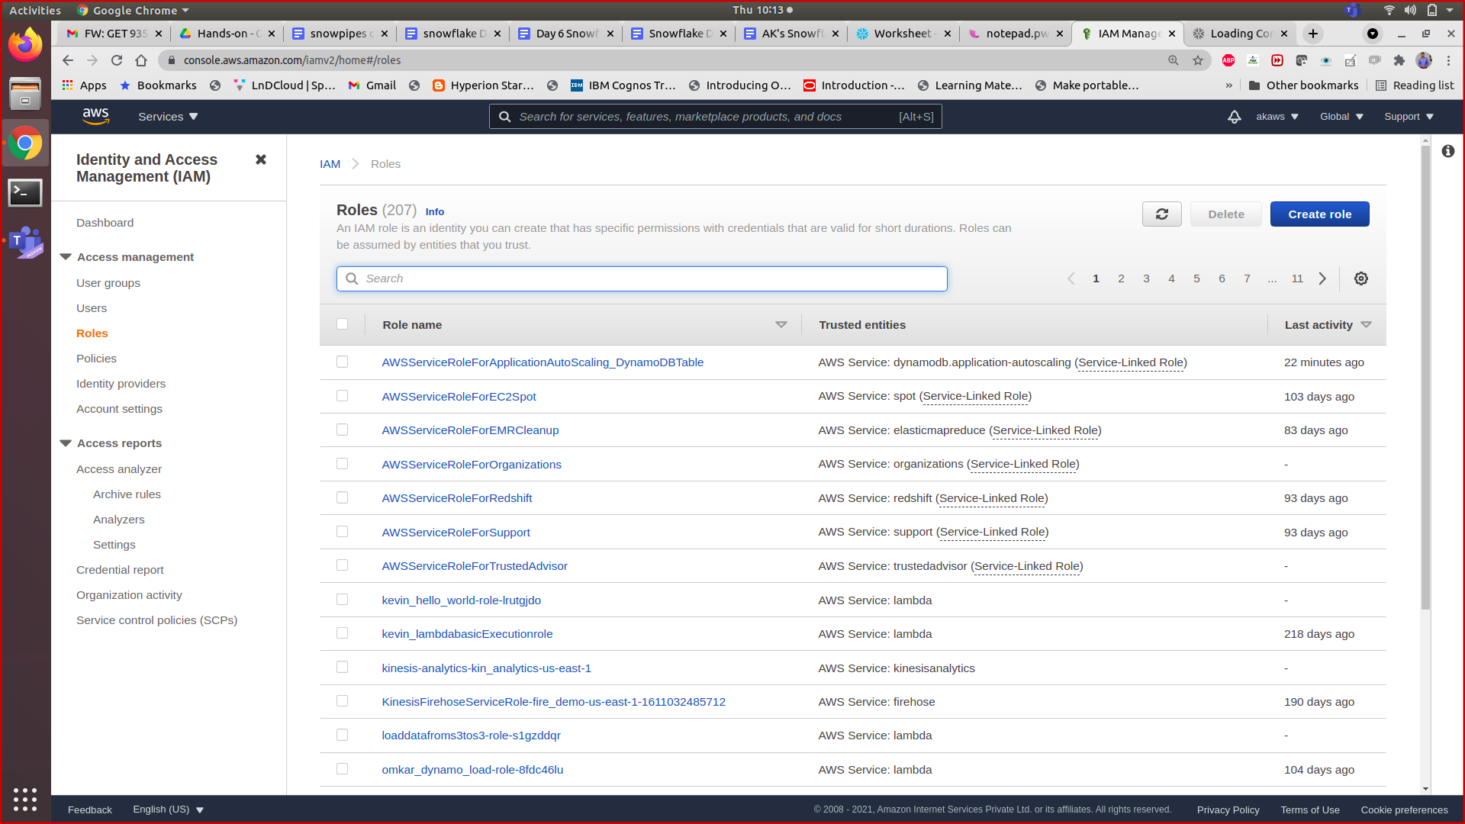

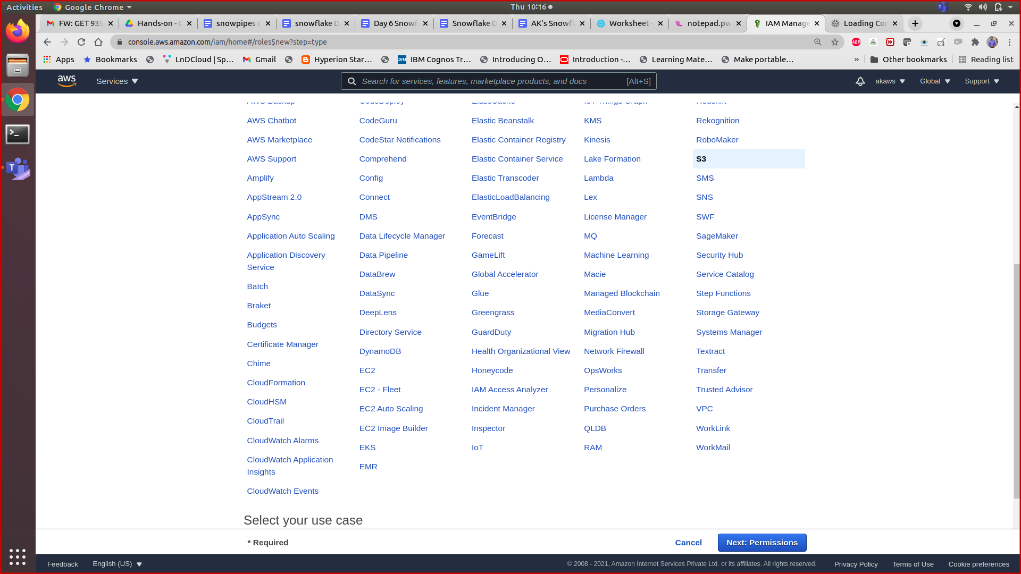

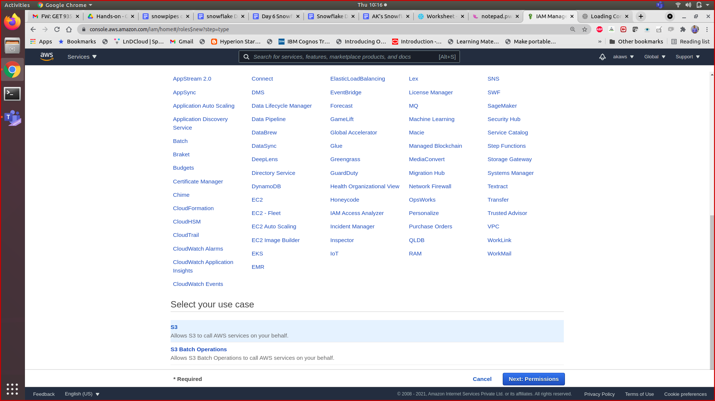

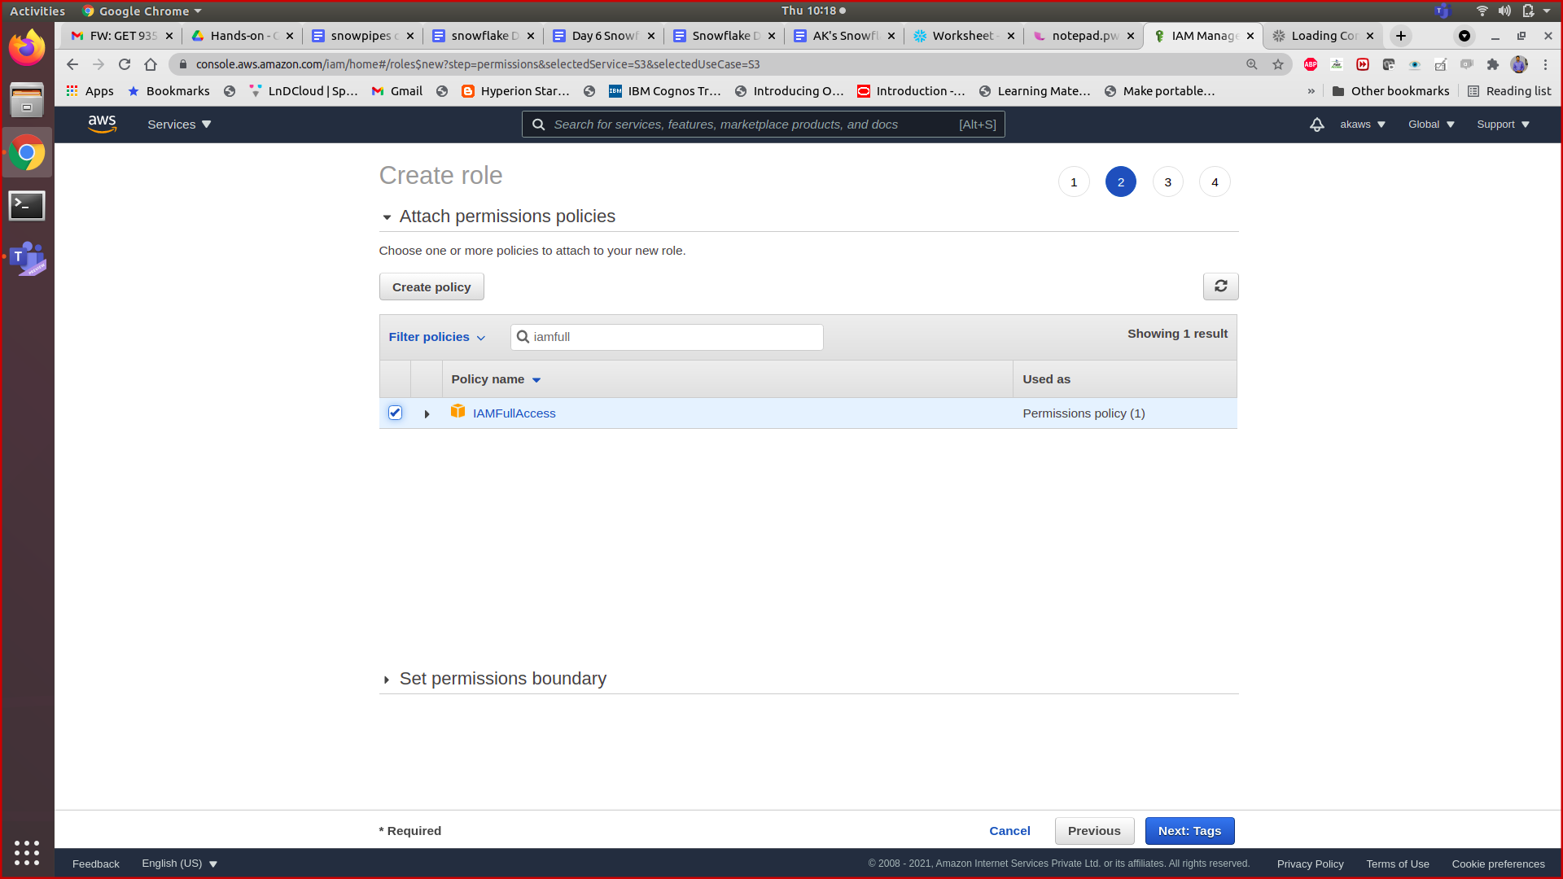

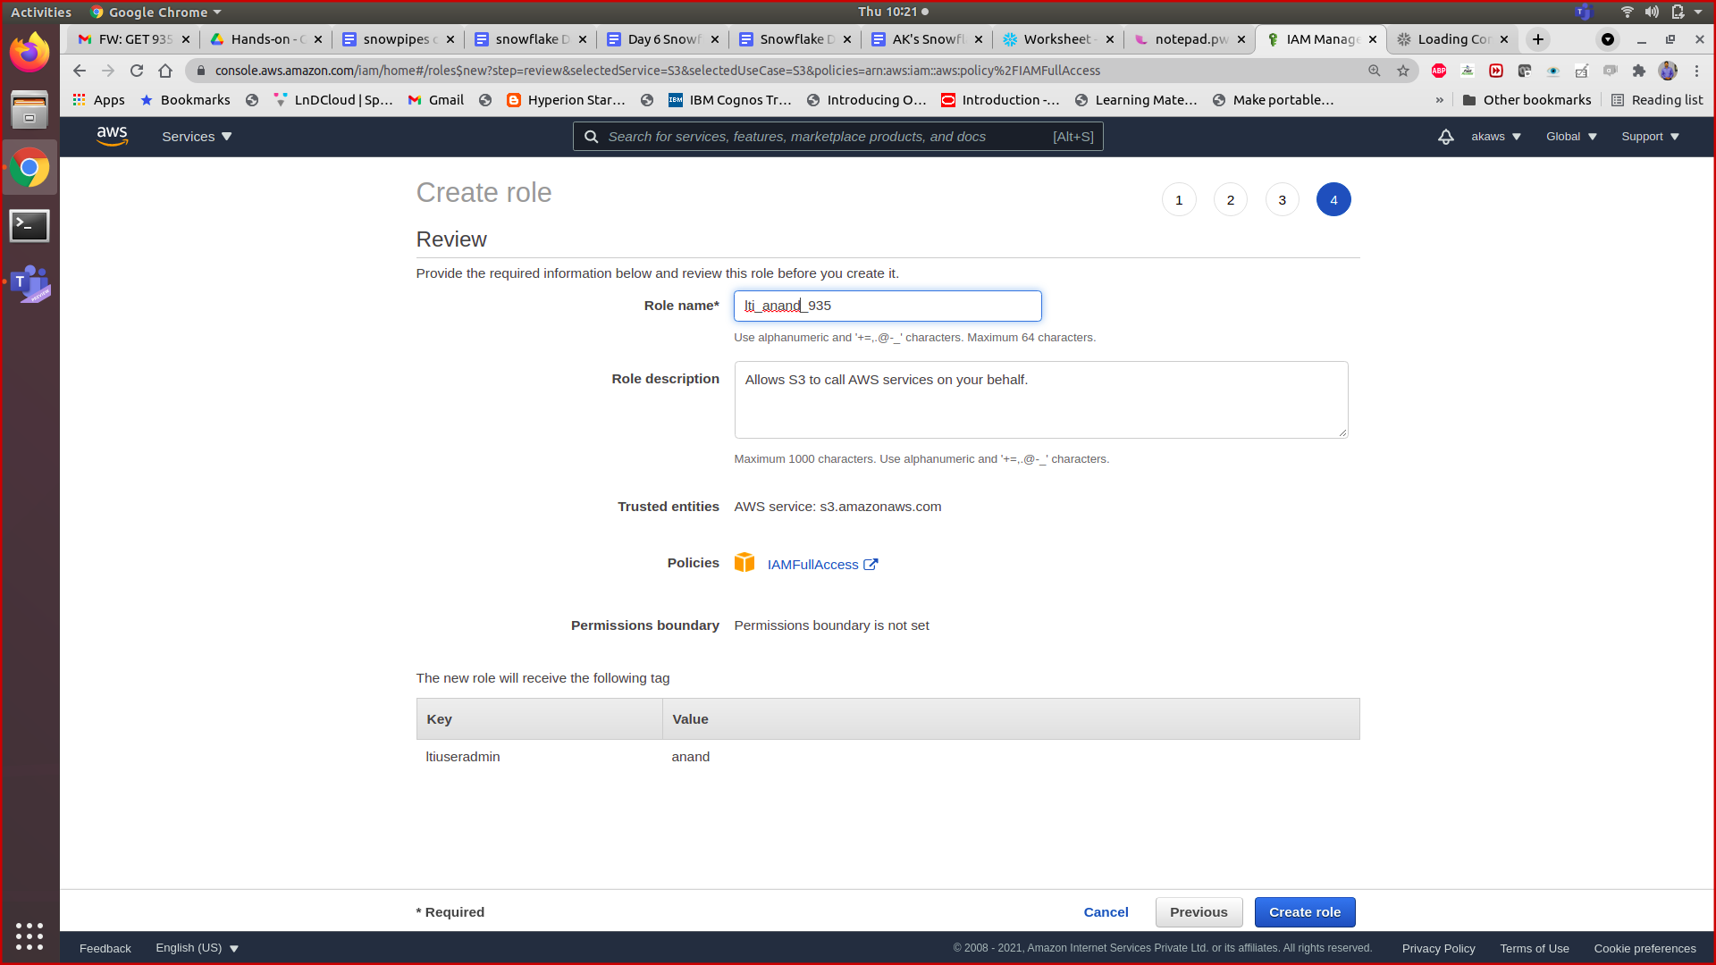

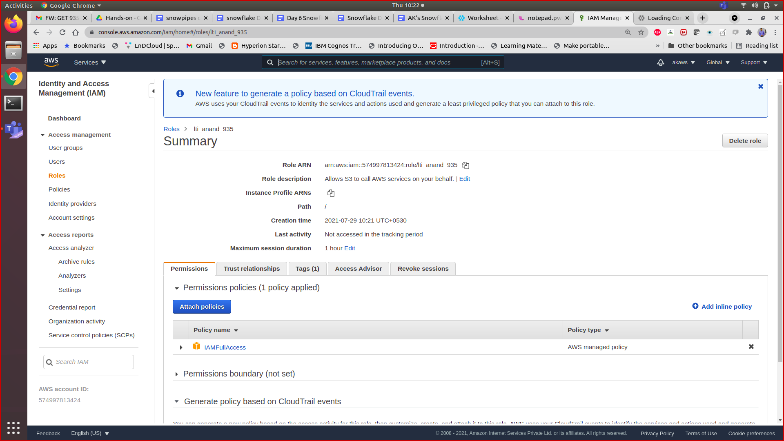

2 . create storage integration with iam arn

create storage integration s3_int

type = external_stage

storage_provider = s3

enabled = true

storage_aws_role_arn = 'arn:aws:iam::574997813424:role/ltisnowflakerole'

storage_allowed_locations = ('s3://lti894/anand/snow');

Desc integration s3_int;

3. Add the trusted relationship

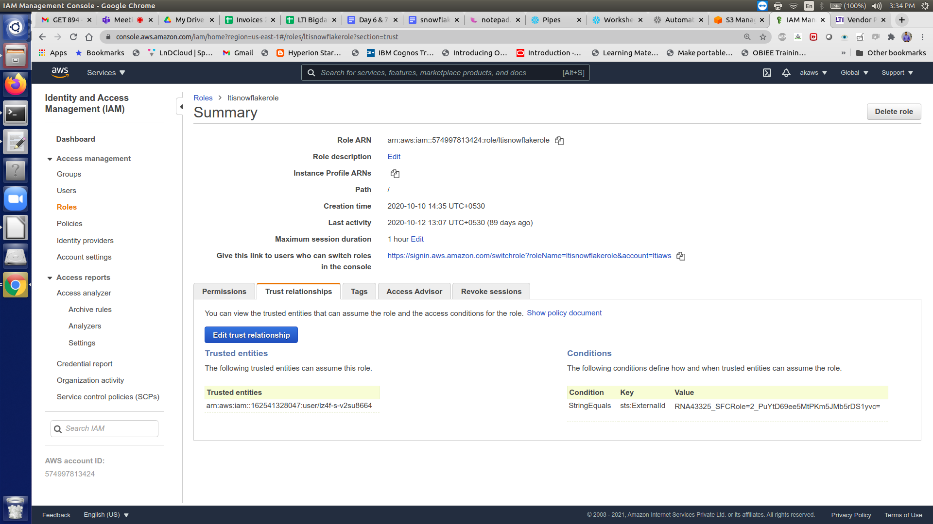

#run desc integration command in snowflake worksheet and get the snowflake arn and external id , replace it IAM role trusted relationship policy document .

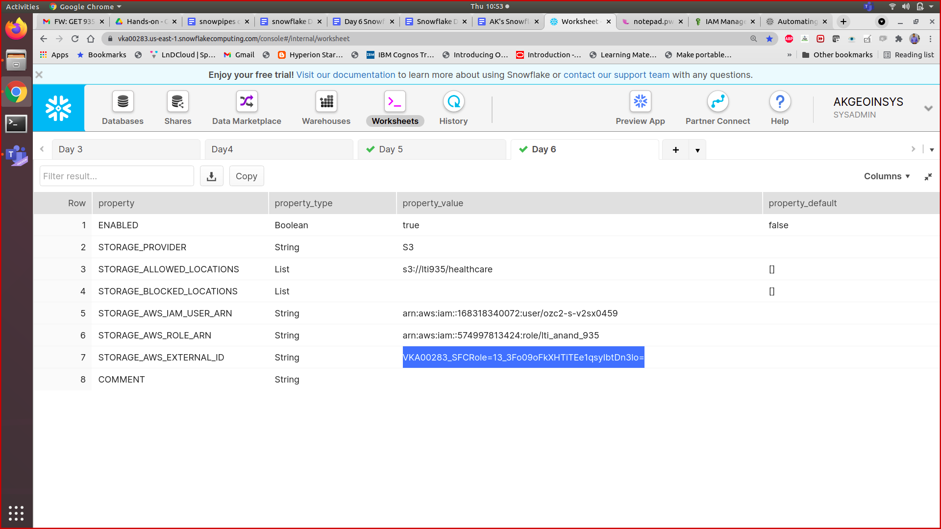

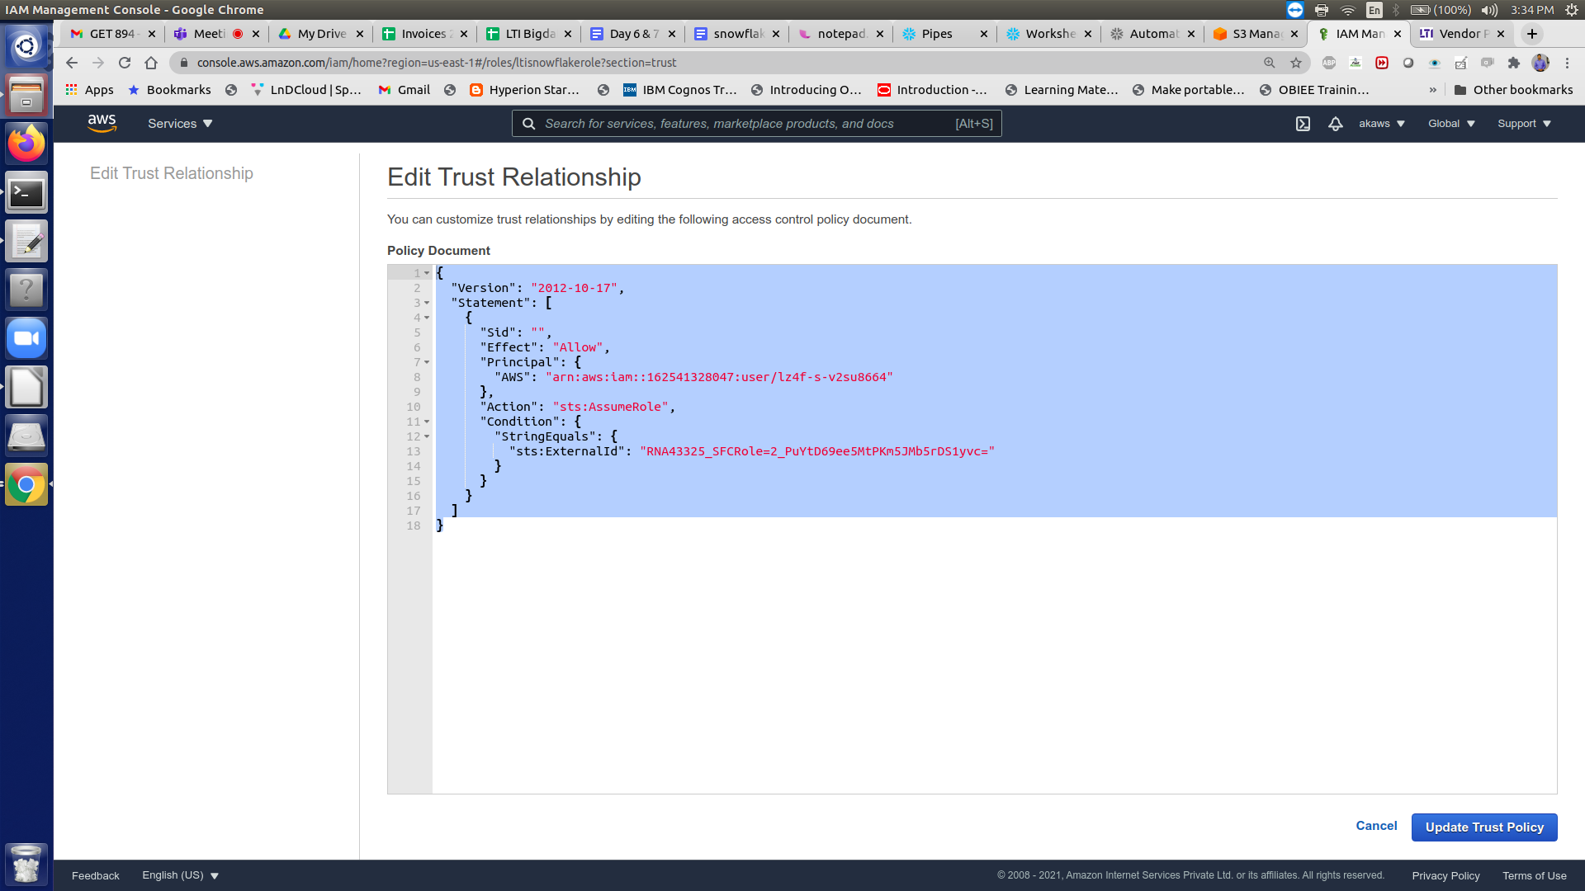

{

**"Version":** "2012-10-17",

**"Statement":** [

{

**"Sid":** **""**,

**"Effect":** **"Allow"**,

**"Principal":** {

**"AWS":** "<snowflake_user_arn>"

},

**"Action":** "sts:AssumeRole",

**"Condition":** {

**"StringEquals":** {

"sts:ExternalId": "<snowflake_external_id>"

}

}

}

]

}

Use the external id and snowflake arn from

desc integration s3_int;

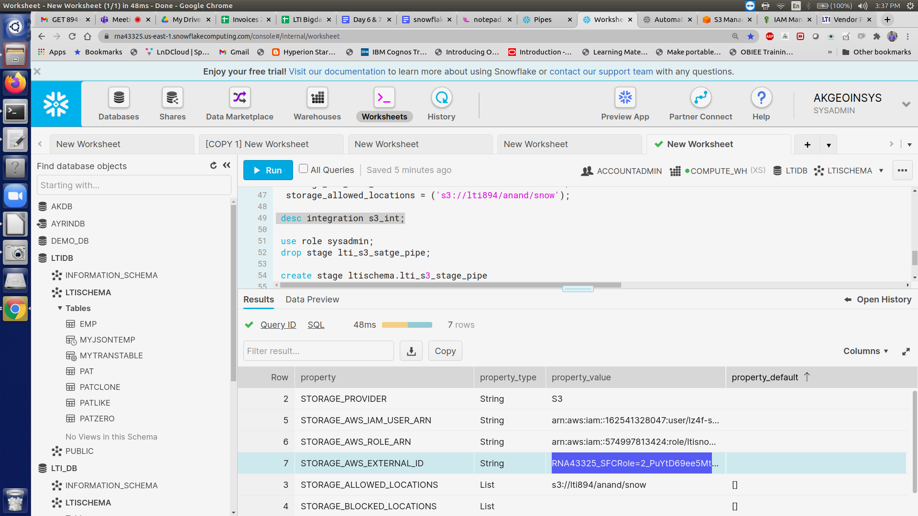

==================

4. Create the external stage for s3 with integration

5. Create the pipe and map source and destination

6. In s3 bucket , create the event notification snowflake with sqs which you get as notification channel from command

Show pipes :

Create event in s3 bucket

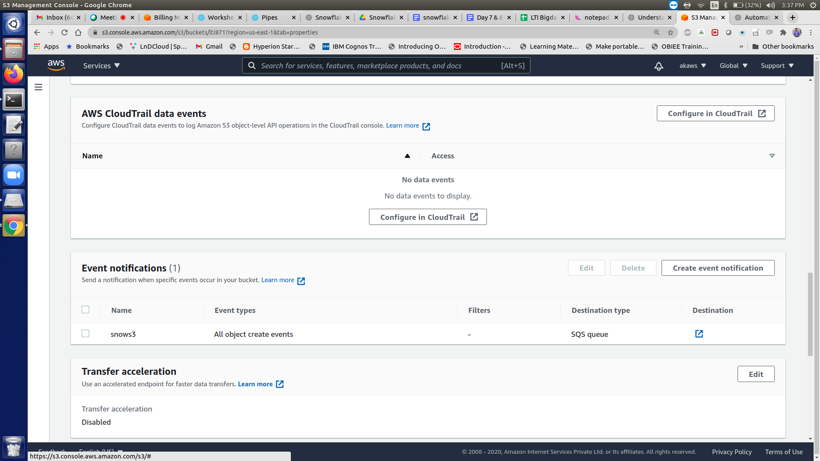

1. Select all object creation

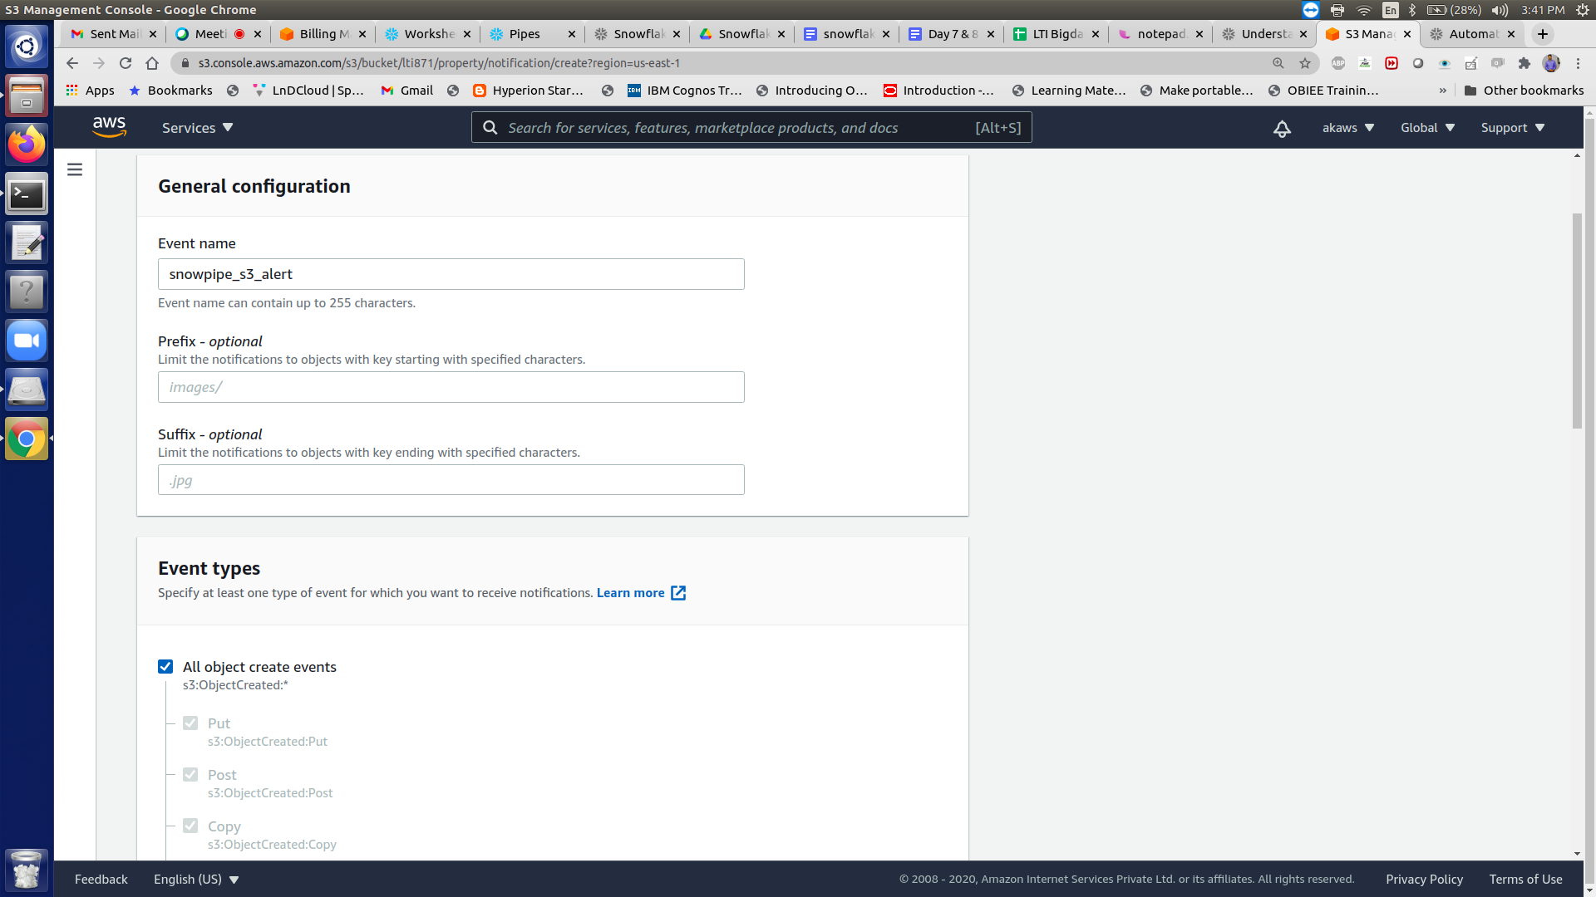

1. Log into the Amazon S3 console.
2. Configure an event notification for your S3 bucket using the instructions provided in the [Amazon S3 documentation](https://docs.aws.amazon.com/AmazonS3/latest/user-guide/enable-event-notifications.html). Complete the fields as follows:
   * **Name**: Name of the event notification (e.g. Auto-ingest Snowflake).
   * **Events**: Select the **ObjectCreate (All)** option.
   * **Send to**: Select **SQS Queue** from the dropdown list.
   * **SQS**: Select **Add SQS queue ARN** from the dropdown list.
   * **SQS queue ARN**: Paste the SQS queue name from the SHOW PIPES output.

8 . snow pipe auto ingest the data from s3 bucket when you create or copy file to the stage location .